Design Documentation of Federal Legislation Tracker

**Background** **2**

**Targeted Users** **2**

**Issue with Current Trackers** **2**

**Requirements of the New Design** **2**

**Improvements by the New Design** **3**

**Pages Design Decisions** **3**

Home Page 3

Overview Page 3

Full Detail Page 3

About Page 3

Future Expansion Recommendations 4

**Low-fi Wireframe** **5**

**Mid/Hi Fi Wireframe - Desktop** **6**

**Mid/Hi Fi Wireframe - Mobile** **7**

# 

# Background

Create a Federal Legislation Tracker to track the legislation status of several cancer related Bills. The Bills are selected important bills that AACI endorses. All the background information and legislation updates will be provided by AACI.

# Targeted Users

Technically all people interested in working in the cancer research field are welcomed as readers for the website. But specifically the website is intended for the members of AACI who want to learn more about the updates of the important Bills endorsed by AACI. The website can provide value to members of AACI, especially for the government relationship manager inside each organization, to learn more about the status of the latest information of endorsed Bills in this one-stop website.

# Issue with Current Trackers

There exists a lot of websites tracking the legislation status of several bills. But either they are not updating, or they are not well designed by the aesthetic of 2020. A lot of the current trackers are really text-heavy, making the readers hard to absorb information. Also, the “updates” fields in a lot of current trackers only shows updates that are “significant” or approved by the government. There are other updates on the Bills that are important, for example latest twitter from the sponsor of the Bill, or latest update on another Bill that is highly related.

# Requirements of the New Design

* Should be aesthetic pleasing
* Should allow dynamic resources, especially should allow AACI staff members to set clickable contents and allow reader to explore more on the important information
* Legislation Tracker and latest information are more important than background information - the tracker is the main reason to initiate this project
* Should be less like a “government” website, but more feel in AACI style
* Should function more like twitter, with easy information shareability and understandability
* Should allow easy updates on the tracker
* Should allow highlights of important updates set by AACI
* Should be as consistent to the AACI existing websites as possible

# Improvements by the New Design

Our new design focuses on solving the issues by considering the following factors:

* Making a modern looking website that is friendly to the reader
* Design a legislation tracker to easily see the latest updates on the bill
* Provide dynamic external links to allow readers to explore the full detail of each bill
* Highlight important fields in the tracker to allow readers understand the status more easily
* Mobile friendly

# Pages Design Decisions

## Home Page

The home page is the page that displays all the endorsed Bill from AACI. Due to the limited number of Bills AACI endorses, the page can directly display all the related bills. There is a distinction between bills that are passed as law and pending Bills, where the later will be more important since there are still chances that the Bills can get passed. The home page follows a card design where it can go to “overview mode” or enter the full detail of the specific bill.

## Overview Page

The overview page is intended to grasp the latest information of the Bill, without overwhelming the reader with all the information available. The intention is to provide readers a quick way to check information and decide if the Bill is worth reading. This page only provides minimum background information, with 5 of the latest updates from the tracker. The overview page allows readers to quickly navigate to other bills in one click.

## Full Detail Page

The full detail page displays the full detail of a specific page, provided by AACI staff members. This page displays all the important background information and facts, as well as the legislation tracker as the main focus. Users can see the latest updates on the legislation status, with a twitter like style, as well as clickable contents to explore more on related resources set by AACI.

## About Page

Standard about page to explain this new project

## Future Expansion Recommendations

We have some future expansion recommendations, if the system grows larger and a plain display of all bills no longer functions best.

1. Have pages showing the bills in order
2. Have a small search bar near the bills heading that searches specific bills quickly
3. Design a web crawl system that automatically searches web content and allow user to select important entries
4. Add expansions the website such that covers current important news (for example COVID bills tracker)

# Low-fi Wireframe

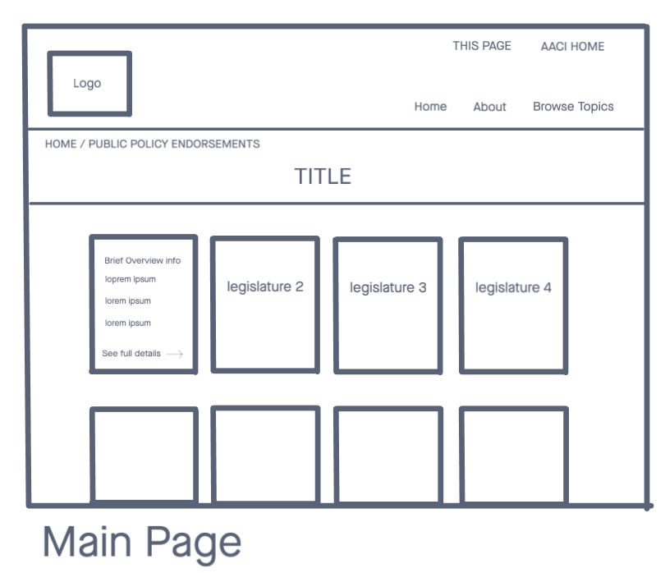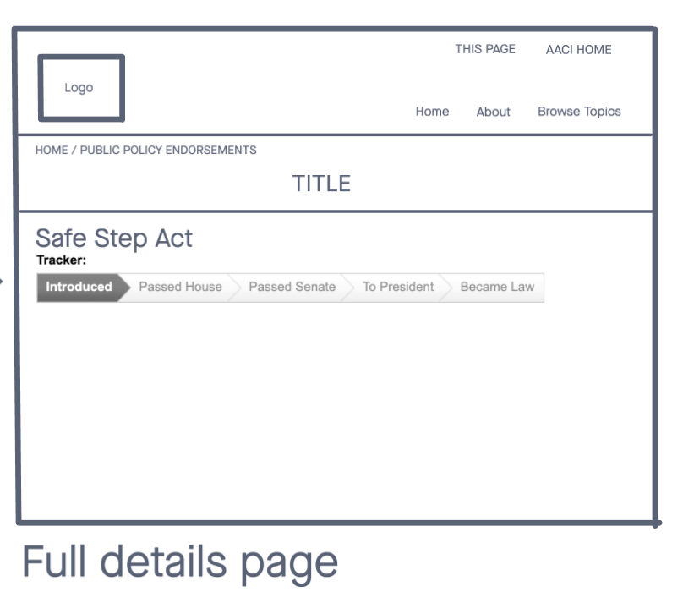

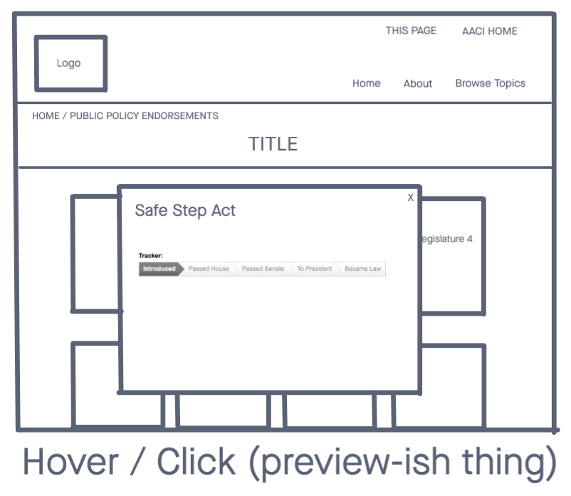

# Mid/Hi Fi Wireframe - Desktop

Figma Template: <https://www.figma.com/file/bAHNVR68ECu7EOzvHZuRDd/AACI-Hi-fi-Wireframe-With-Mobile?node-id=0%3A1>

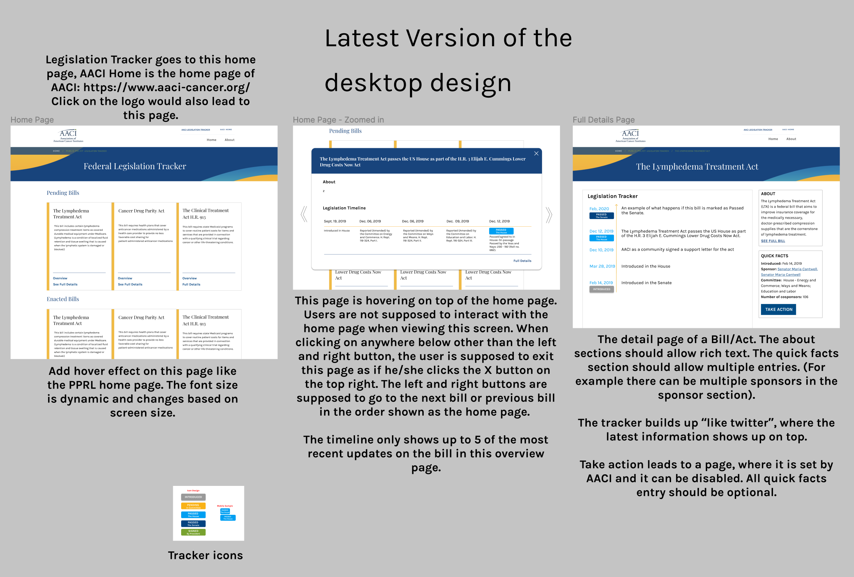

# Mid/Hi Fi Wireframe - Mobile

